**Decision Tree Classifier**

All theoretical parts are same as ‘Decision Tree Regressor’ but only there is a small difference in how entropy is calculated with continuous numerical target and categorical target values

Entropy calculation for categorical target is very simple while entropy calculation for numerical target is a bit complex and performance intensive

In this technique we do not require to learn any mathematical formula calculation as it is simple nested if-else tree

* What is Entropy
* How to calculate Entropy
* Why we need gini while it works as entropy
* Handling numerical data instead of categorical data
* Decision tree hyper parameters
* Dtreeviz library to visualize tree

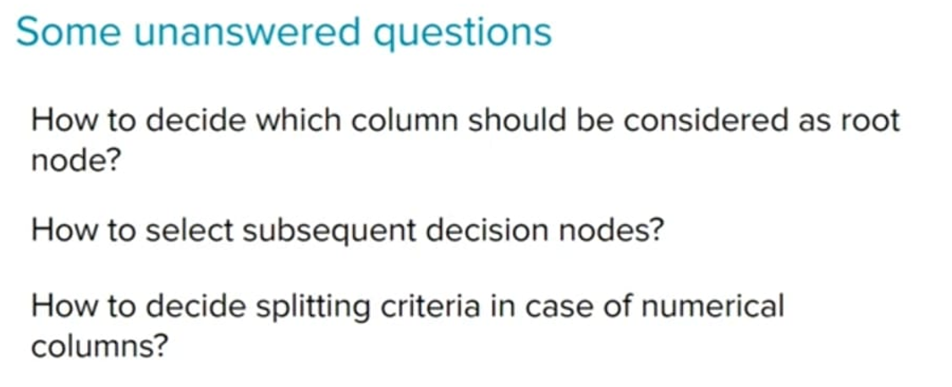

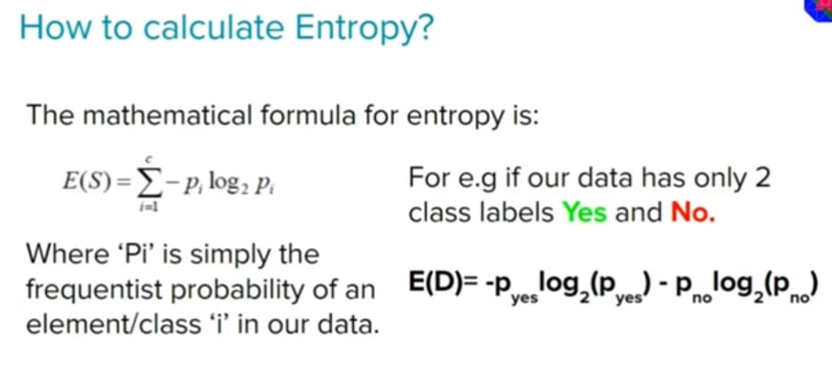

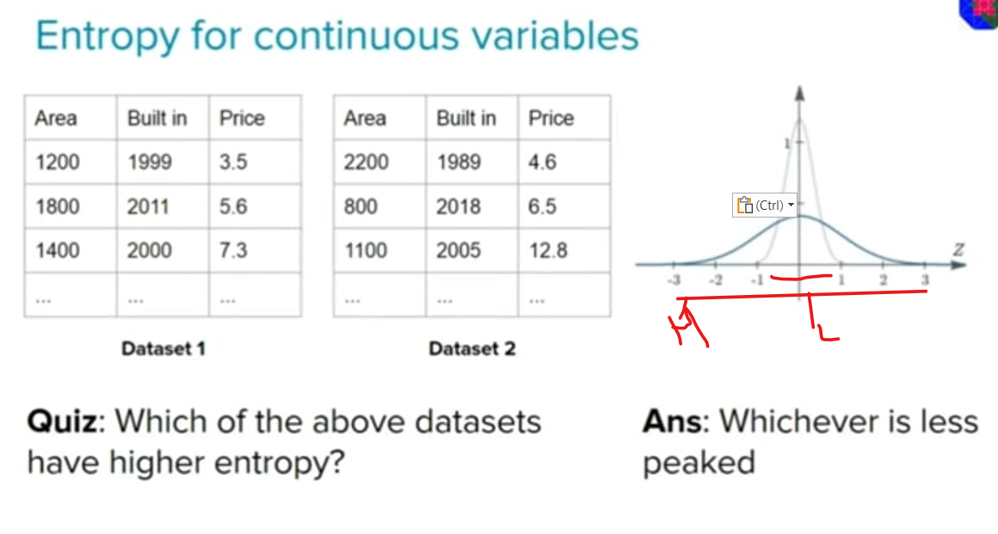

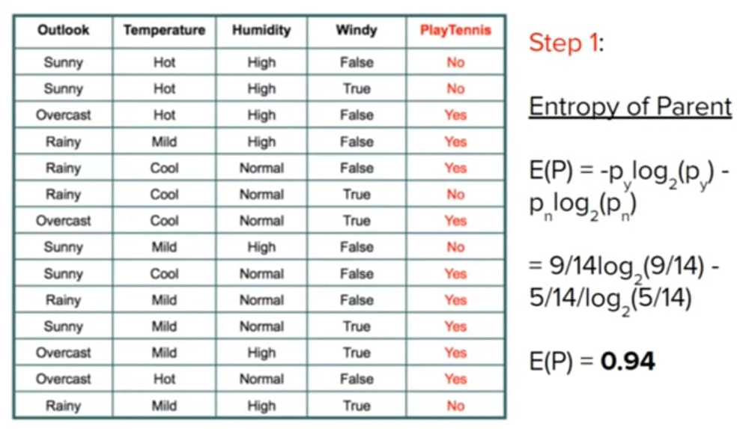

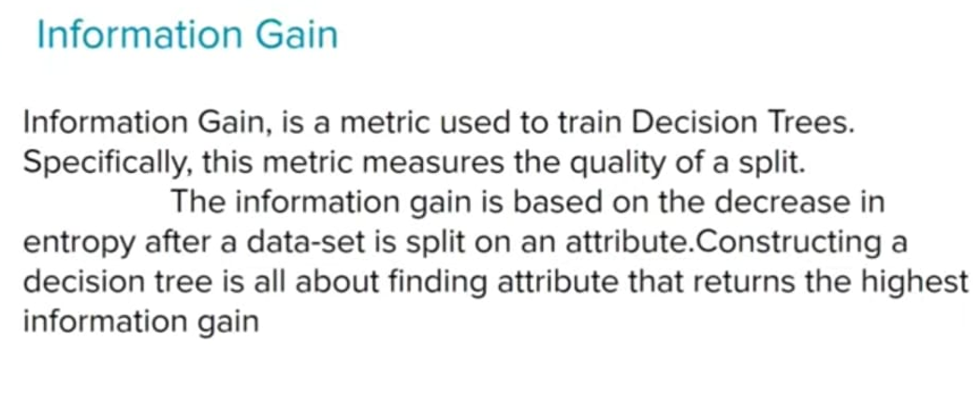

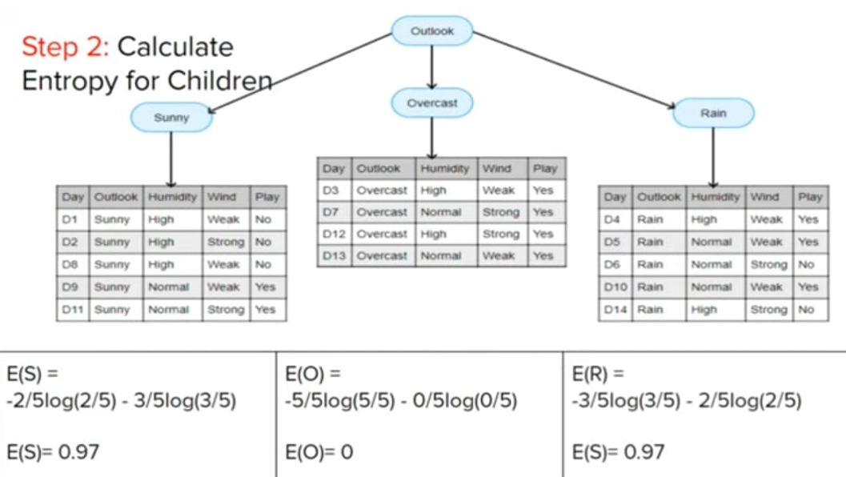

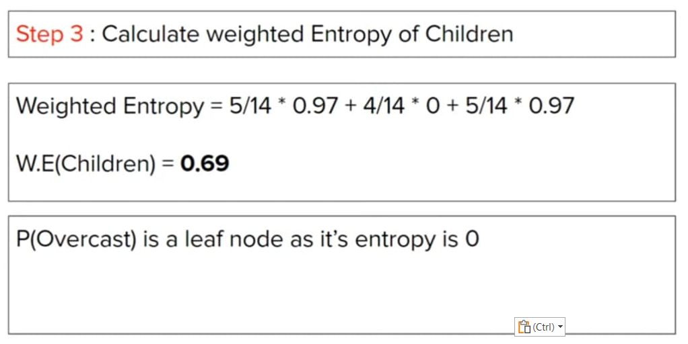

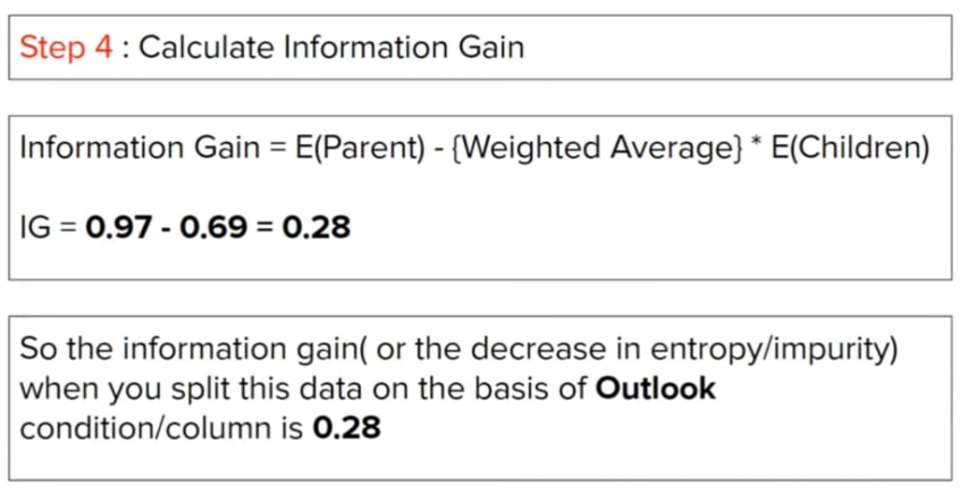

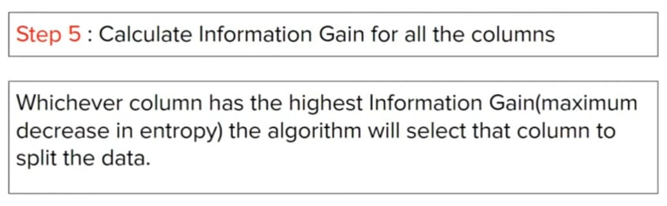

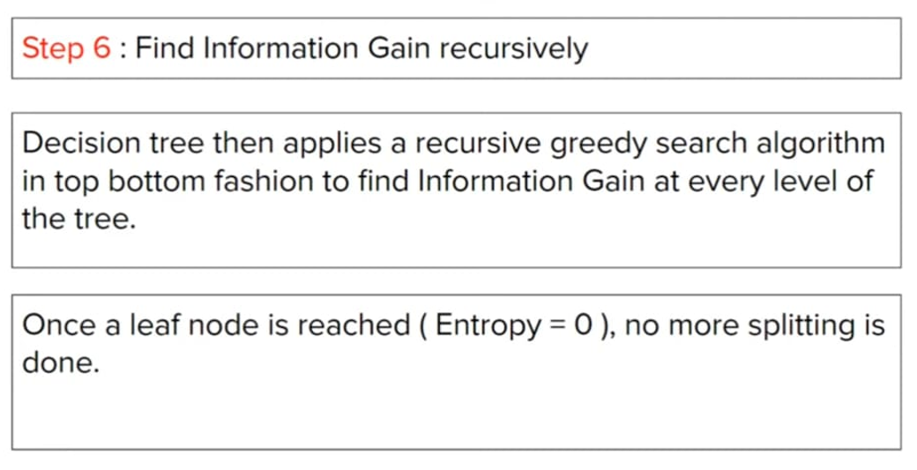

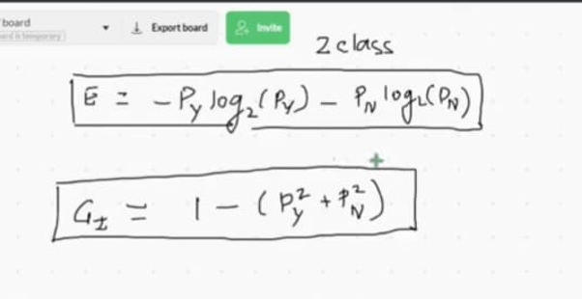

**Dtreeviz library:**



